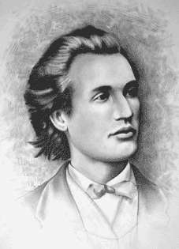

BAREM CLASA a IV a

Subiectul I ( 5X10 puncte )
1 | 2 | 3 | 4 | 5 | 6 | 7 | 8 | 9 | 10
B | A | C | A | B | B | A | D | A | C

Subiectul II (20 puncte
11. a+b+c=34…………………………………………………………………………….2p
971:9 =107 rest 8…………………………………………….………………………2p
a-8=b-a=c-b+2……………………………………………………………..……...….2p
b=2a-8………………………………………………………………………..………2p
a+b=c+10……………………………………………………………………..………2p
c+10+c=34………………………………………………………………..………..….1p
2c=24…………………………………………………………………..………..……..1p
c=12………………………………………………………….………….……….........1p
a+b=22…………...........................................................................................................1p
Dar b=2a-8
Deci 3a=30………………………………………………………………..……………2p
a=10………………………………………………………………………..............…..2p
b=22-10...……………………………………………….…………..…….....................1p
b=12................................................................................................................................1p

